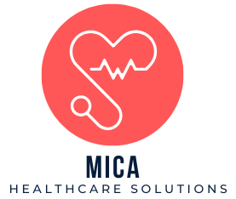**Medical Invoice**

**MICA Healthcare Solutions**



|  |
| --- |
|  |

**Bill From** **Bill To** **Invoice No: MHS-12354-24**

**Name:** Dr. John Smith **Name:** Solutions Mica **Invoice Date:** 11/11/24

**Street Address**: RoundHill Ave **Street Address:** 8000 York Rd  **Due Date:** 11/11/24

**City:** Baltimore **City:** Towson  **Account No:** 554854545454

**Zip Code**: 21240 **Zip Code:** 21252

**Phone:** (413)-324-XXXX **Phone:** (410)-704-XXXX

|  |  |  |  |  |
| --- | --- | --- | --- | --- |
|  | | | |  |
| **Medical Services** | **Medication** | **Patient** | **Rate($)** | **Total($)** |
| General Consultation | Pain Relief Pill | Solutions Mica | 100.00 | 100.00 |
| Blood Test | None | Solutions Mica | 50.00 | 50.00 |
| X-ray | None | Solutions Mica | 75.00 | 75.00 |
| Emergency Care | Antibiotics | Solutions Mica | 50.00 | 50.00 |
| Vaccination | Vaccines | Solutions Mica | 80.00 | 80.00 |
|  |  |  | **Subtotal** | $505.00 |
|  |  |  | **Tax (5%)** | $15.00 |
|  |  |  | **Delivery Fee** | $10.00 |
|  |  |  | **Total** | $530.00 |

MICA Healthcare Solutions

8000 York Rd, Towson, MD, 21252

(410)-704-XXXX

XXXXX@Healthcare.solutions